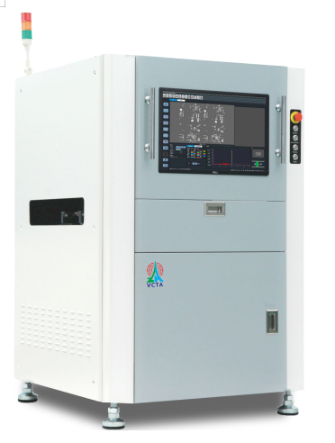

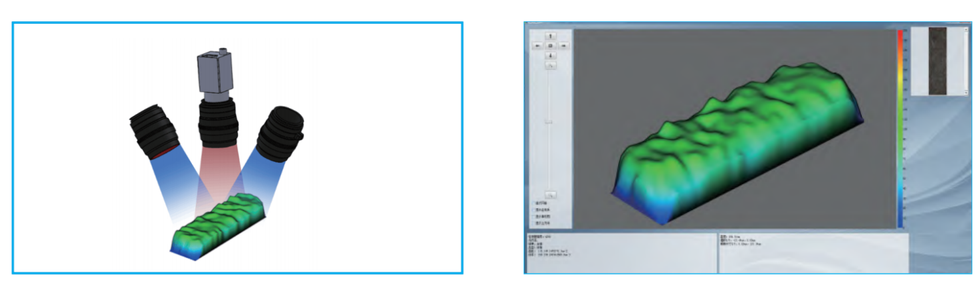
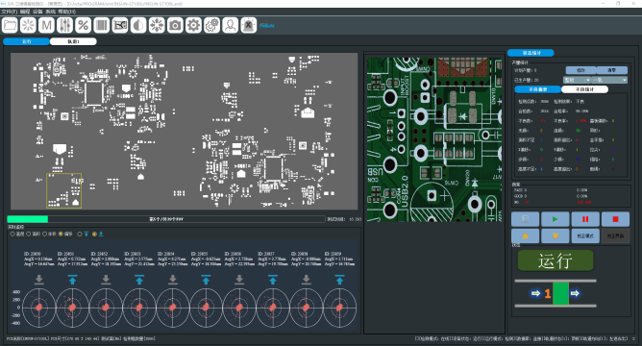
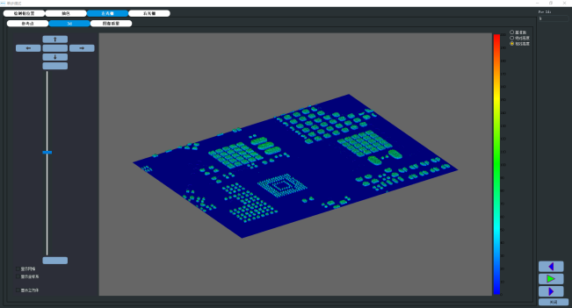

Features:
• PMP technology based on White Moire fringe light，height resolution 0.37um
• Dual 3D Projection systems to avoid shadow and reflection
•Digital High Speed Camera 5M Pix，and 12M, 20M for options
• High Speed inspection capability
• High accuracy and repeatability（CPK 1.67，GRR<1%@3sigma)
• Auto warpage detection
• Solder paste or red gum detection
• 2D/3D true color image display
• Simple Programming, average 5-10 mins
• Gerber 274D/X、CAD，Offline program，Bare Board Teach
• Powerful SPC software
• Automatic 1D 2D Bar Code reading
• Support close loop function with printer machine
• Support MES connection

Specifications
CATEGORY | ITEM |  | Specifications
Inspection System | Camera |  | Digital High Speed CCD 5M Pixel  (12MP for Option)
Inspection System | Lamp-house |  | Ring R/G/B/W LED
Inspection System | FOV |  | 45*36mm(18μm） @5MP  38*30mm(15μm） @5MP  48*36mm(12μm) @12MP  40*30mm(10μm) @12MP
Inspection System | Speed Per FOV |  | 0.3~0.45s
Inspection System | Items |  | Paste Solder/Red gum: Volume、Area、Height、Shape、Shift、Bridge、Overflow
Inspection System | Defects |  | Missing、Shift、Excessive, insufficient, Bridge、Pull、Collapse, Shape、Gold finger、Height、Overflow
Inspection System | Height Range |  | 1~1000um
Inspection System | Area Range |  | 0.15mm×0.15mm~10mm×10mm
Inspection System | Height Detection Resolution |  | 0.37um
Inspection System | Height Accuracy on Certificated Target |  | 1um
Inspection System | Height/Area/Volume Repeatability |  | <1%@3sigma
Inspection System | GR&R |  | <10%
Mechanism System | PCB Conveyor |  | Bottom-up fix; Auto transmit and width correct based on SMEMA;Height: 900±20mm
Mechanism System | PCB Size |  | 50x50mm~510x460mm  (Larger for option on cost)
Mechanism System | PCB Thickness |  | 0.5~5.0mm
Mechanism System | Max PCB Warp |  | <2mm
Mechanism System | X,Y Platform | Driver | AC servo system
Mechanism System | X,Y Platform | Orientation | <1μm
Mechanism System | X,Y Platform | Moving Speed | 700mm/s
Software System | Operation System |  | Microsoft Windows 10 proX64
Software System | Control&  Recognizing | Characteristics | Dual 3D Projection，avoid shadow and reflection
Software System | Control&  Recognizing | Operation | Graphic programming, Chinese, English
Software System | Control&  Recognizing | Result | 2D/3D true color
Software System | Control&  Recognizing | MARK | 2 Common Marks can be chosen, or muti-marks can be chosen and skip function of array boards
Software System | Control&  Recognizing | Programming | Gerber 274D/X、CAD，Offline program，Bare Board Teach
Software System | Control&  Recognizing | Barcode Recognition | One dimensional code, 2D Barcode
Software System | Control&  Recognizing | MES Support | Standard port available
Software System | SPC | Offline SPC | Support
Software System | SPC | SPC Chart | Any Time Chart(（excel、jpg、bmp ），histogram and control chart to show volume、area、height、shift
Control System | Computer |  | Industrial computer：Intel Quad-core CPU Memory:32G，Hard disk:2TB
Control System | Display |  | 19 inch TFT
Others | Air Supply |  | 0.5MPA,40cm³/min
Others | Machine Dimensions(L*W*H) |  | 1148x1260x1660mm
Others | Weight |  | About 750 KG
Others | Power Supply |  | AC220V±10%，50/60Hz，1200W
Others | Working Environment |  | Temperature: 10-40℃，Humidity: 30-80%RH

